**A.L.E.C. - Intelligent Chatbot for CSED**

**Introduction**

The website of Computer Science and Engineering Department contains all the information required by students. But it is very difficult to search for the information on the site without any prior knowledge of where it could be found. Students need to enquire about the department, its courses, subjects, past projects, etc. They need to search through the website to look for answers.

A.L.E.C. stands for Artificial Linguistic Enquiry Chatbot. It will act as a one place solution to all the queries asked by the students. It will help the students to get the desired information at the right time. It will be like a virtual assistant to which we can ask questions and get instant answers.

**Problem Statement**

A.L.E.C. knows about all the information related to CSED. It is trained on a large dataset containing all information about department. The whole working of A.L.E.C. is divided into three modules. Following are the three modules:

* **Users**

This module consists of two types of users:

1. Student
2. Admin

**Working for user Student:**

* Student logs into the chatbot
* Student asks query to the chatbot
* Chatbot extracts keywords from the query
* It applies pattern matching to the keywords
* Based on pattern matching it looks for the suitable answer in the database
* It generates the desired result

**Working for user Admin:**

* Admin logs into the chatbot
* She/he can view the queries submitted by the students which were unanswered or to which the answer was not found in the database
* Admin can then add the query to the database along with its answer
* She/he can manage the information in the database
* **Chatbot Application**

This is the GUI interface provided to the students to interact with the chatbot. It consists of a chat like view.

**Working:**

* User types a message and presses the send button
* The answer is returned to the user in dialog format
* **Notice Board**

This module is defined for displaying the important notices issued by the department. Students can view the noticeboard by just typing ‘Notice’ in the chatbot.

**DFDs**

**Level 0:**

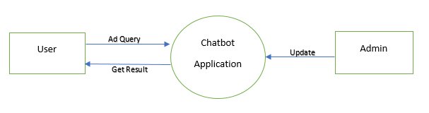

**Level 1:**

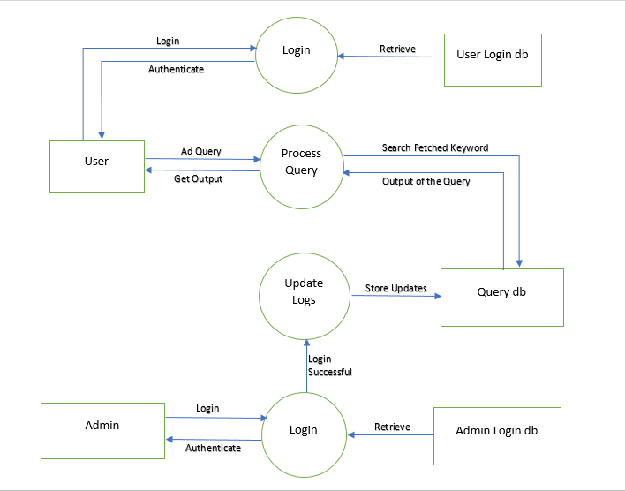

**Level 2**

**Level 2.0:**

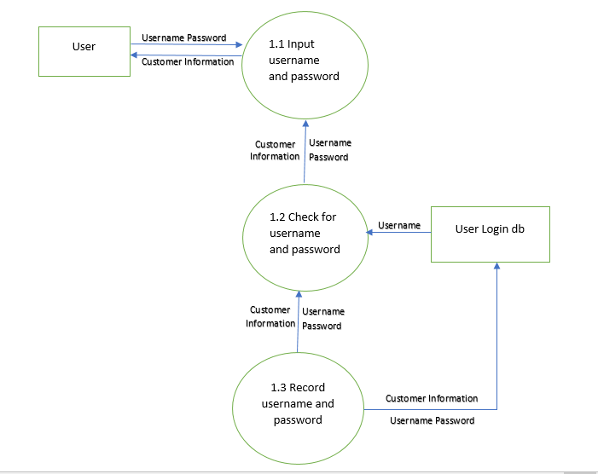

**Level 2.1:**

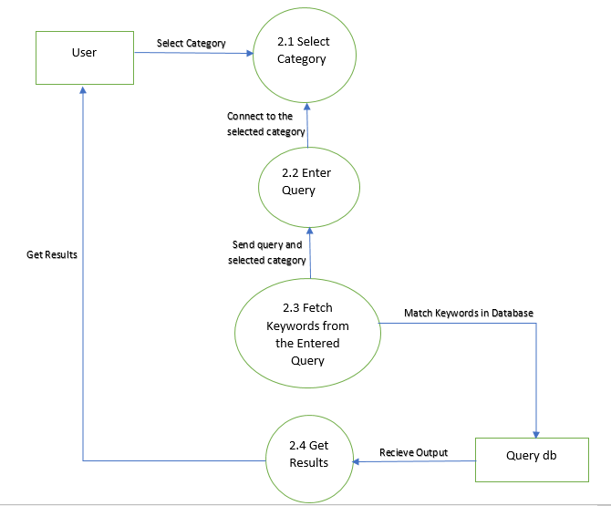

**Level 2.2:**

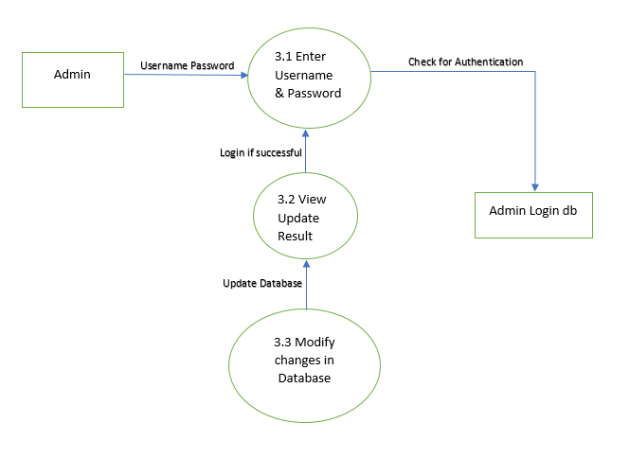

**Features**

* Provides user friendly chat view.
* Provides reference links.
* Provides tucked information like scholarships, events, etc.
* Live notice board and announcements.

**Future Enhancements**

* Admin can manage unanswered questions.
* User can submit the answers.

**Tools Used**

1. Natural Language Processing (NLTK)
2. Pattern Matching
3. HTML, CSS
4. PHP

**Referfence Links**

1. https://drive.google.com/file/d/0B-tCvLzyt01FYlQ2dVRBWEtTNkE/view
2. https://www.cleverbot.com/
3. https://www.youtube.com/watch?v=s4g998Xgwoc